- Create one IAM user and assign EC2 and S3 full access roles.
First we go to IAM service and create new iam user -click on the provide user access to the aws management console
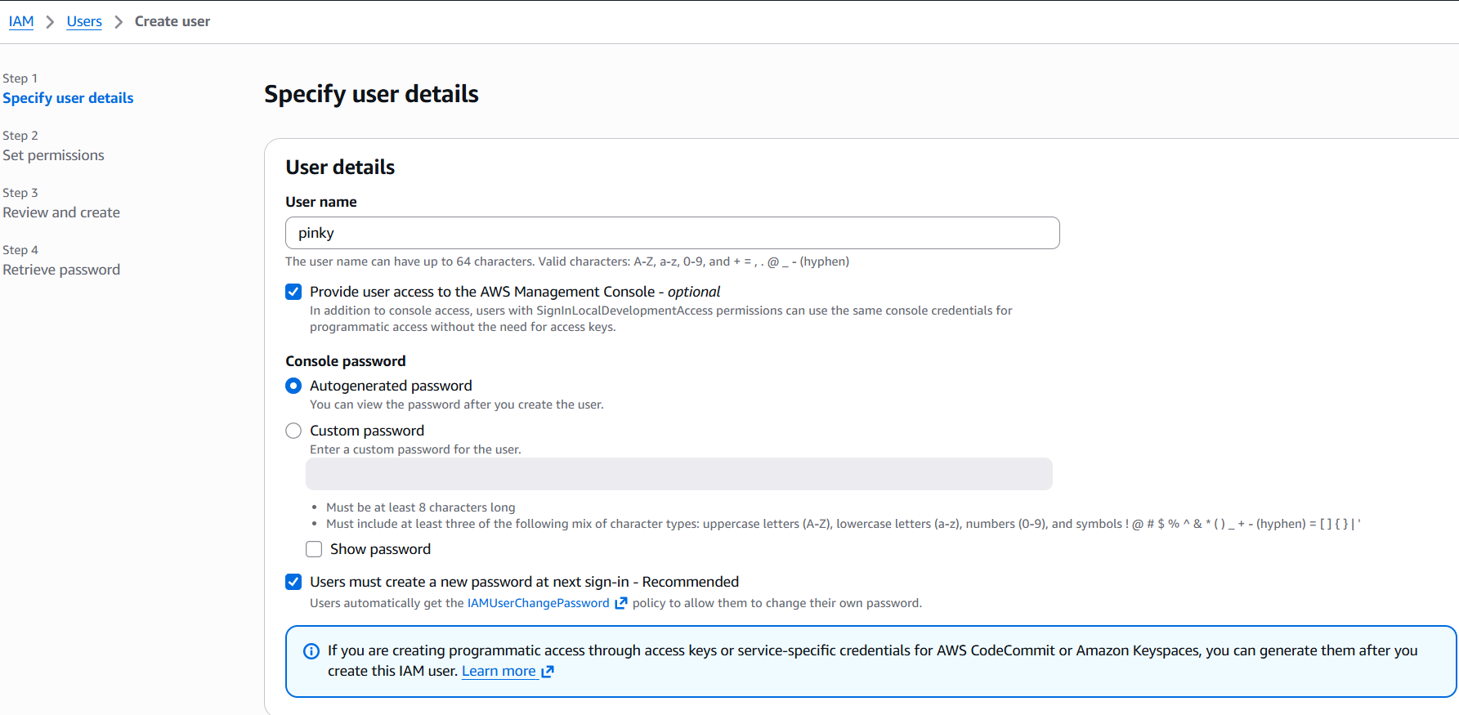
Assign permissions policies- Attach policies directly – it well be give the access rights
Permissions polices -select S3 full access EC2 full access it well be access full control permissions
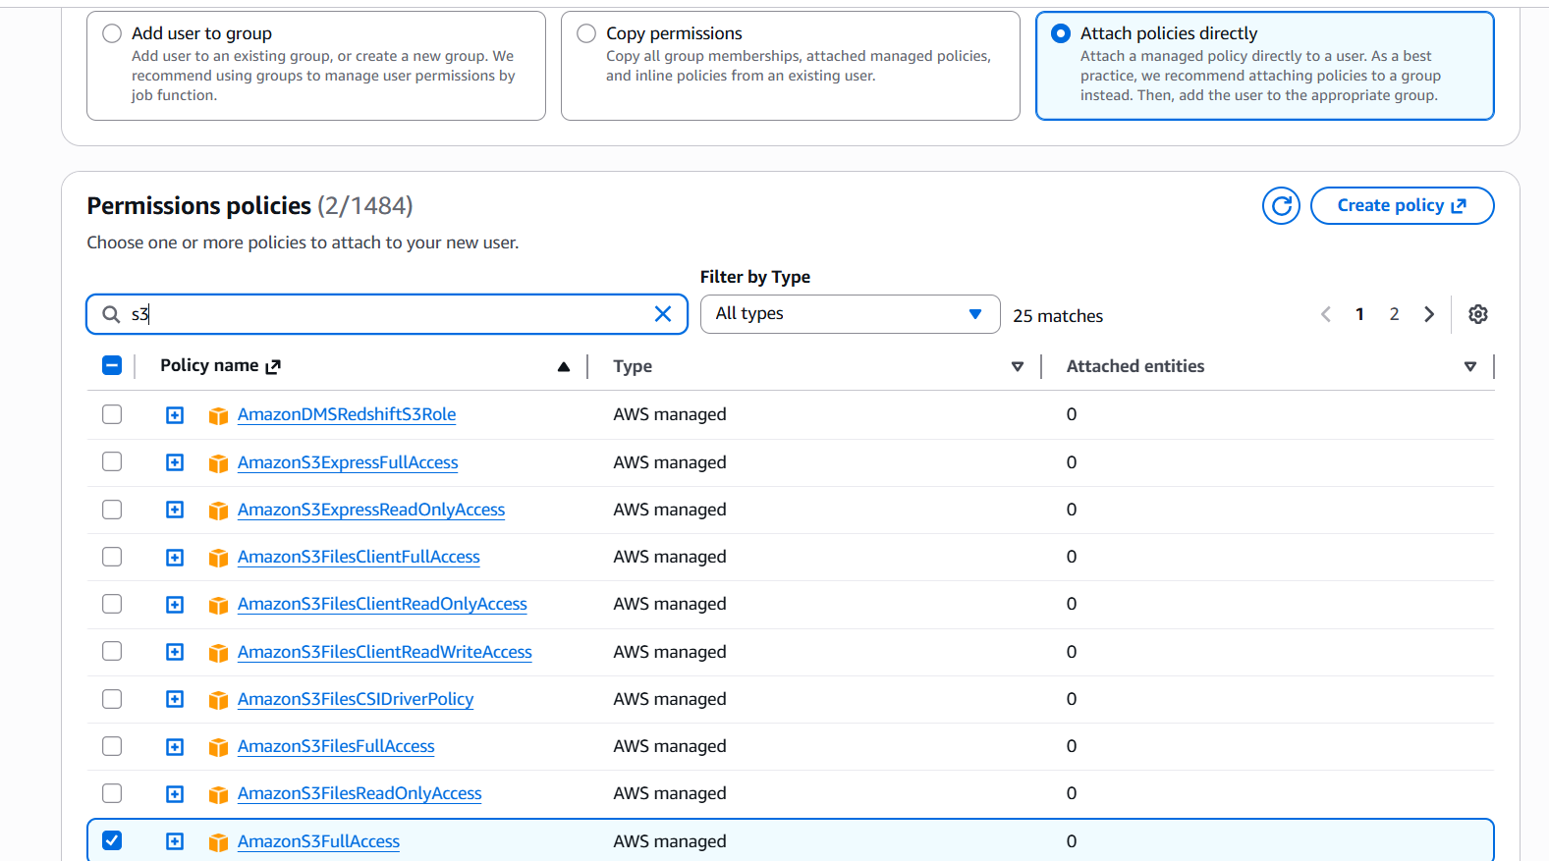

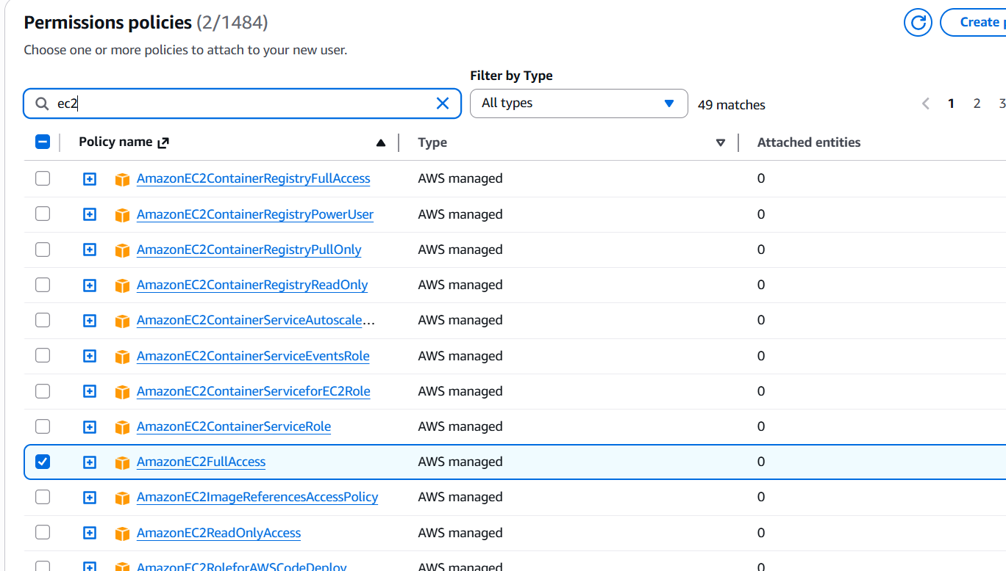

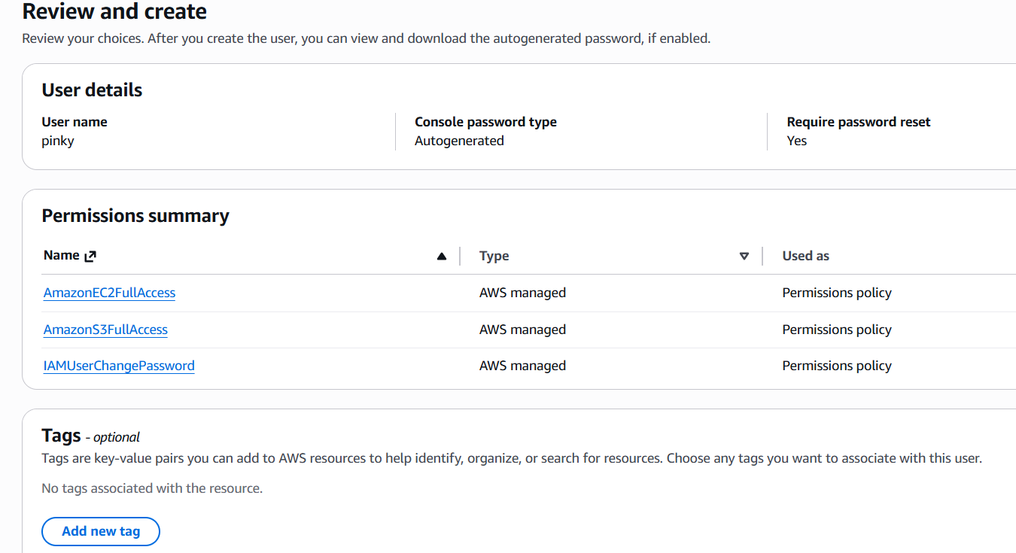

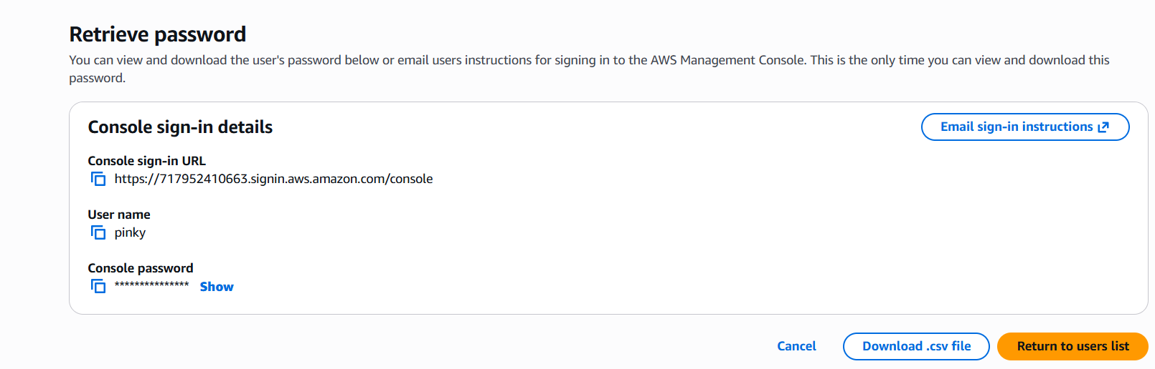
I have loginned to IAM user
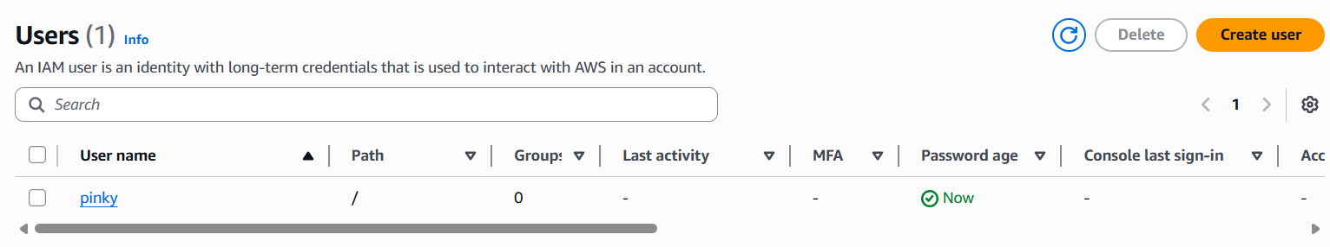
- Create one group in IAM and assign read access for EC2.
Create IAM Group
- In IAM Dashboard → Click User Groups
- Click Create group
- Enter group name
Attach Permissions
- Under Attach permissions policies
- Search and select:
  - AmazonEC2ReadOnlyAccess
This policy allows users to:
- View EC2 instances
- Check instance status
- View configurations and resources
- Cannot create, modify, or delete resources

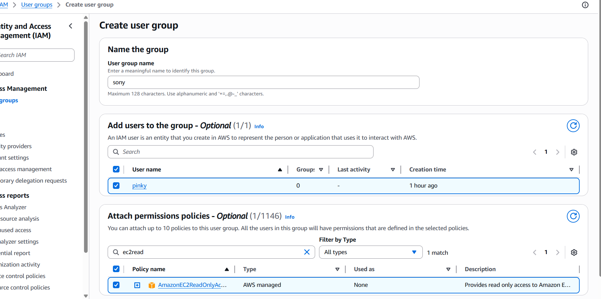
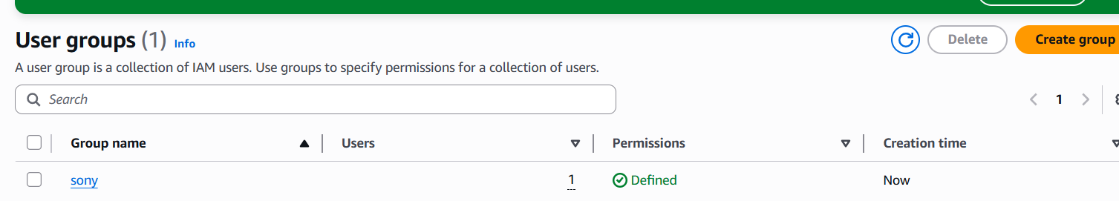
- Create a new user named "Devops" and add to the group created in task 2.
Create New IAM User
- In IAM Dashboard → Click Users
- Click Create user
- Enter username: Devops
- Click Permissions options
- Next click task two user groups

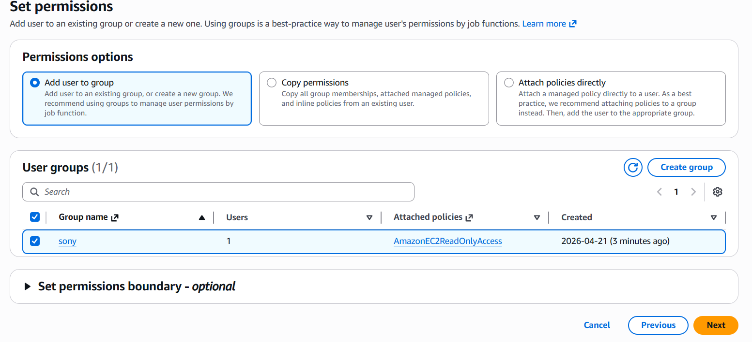

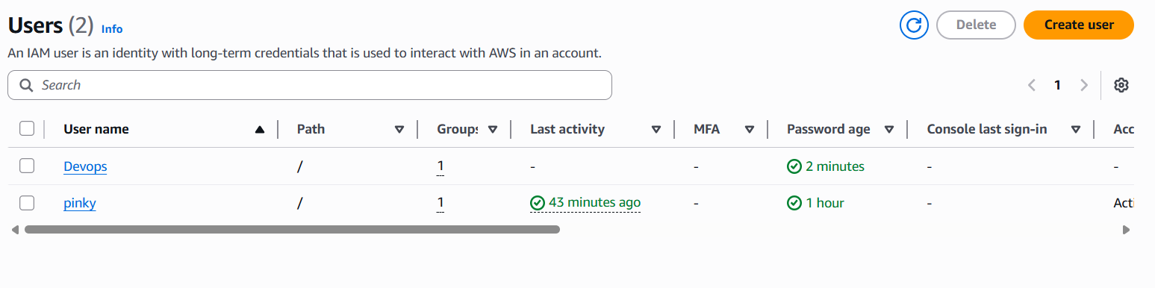
4. Write a bash script to create an IAM user with VPC full access.
I have created a file and wrote a bash script to create an IAM user with VPC full access

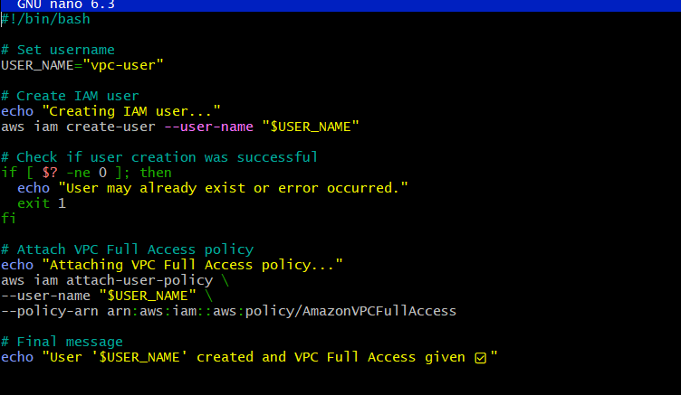
Allowed permissions to execute
Chmod 777

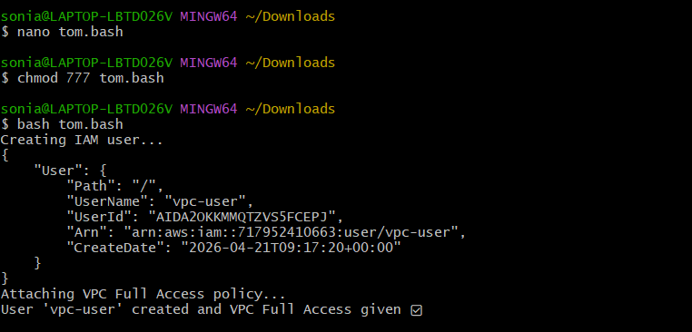
- Checked whether the user is created or not

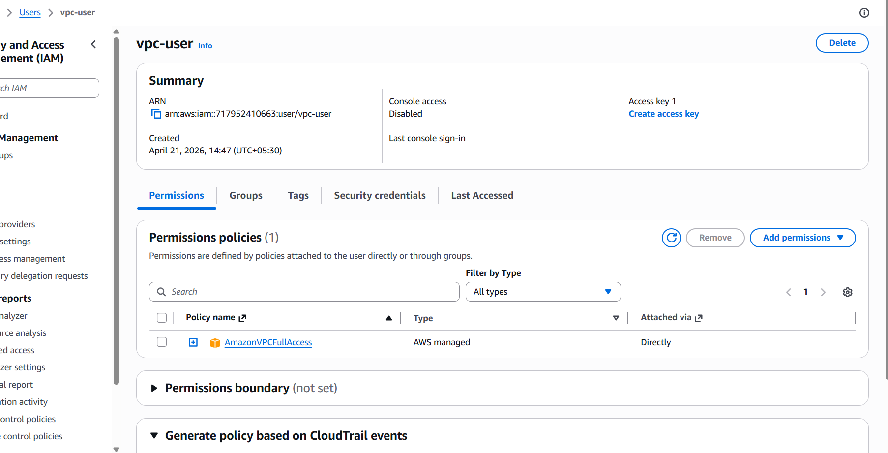
5. Create an IAM policy to allow EC2 access for a specific user in specific regions only.

First I have created policy

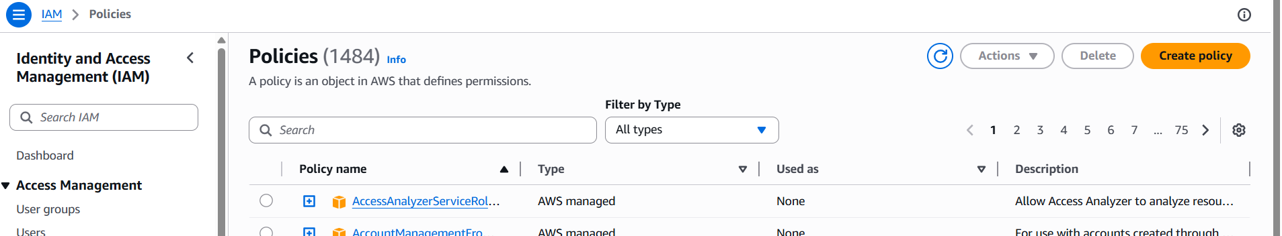

I have added json policy

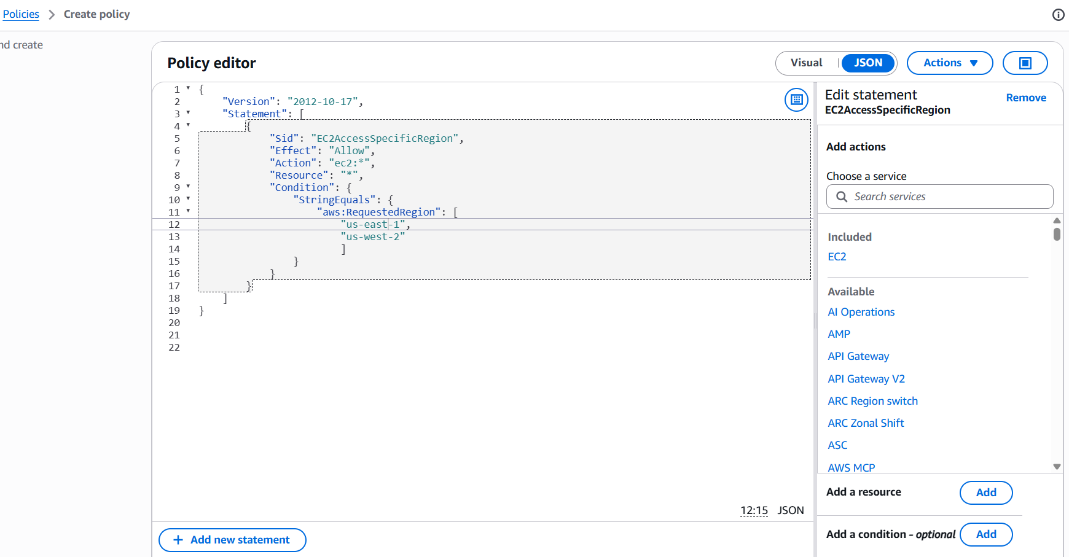
Here I have added a policy name

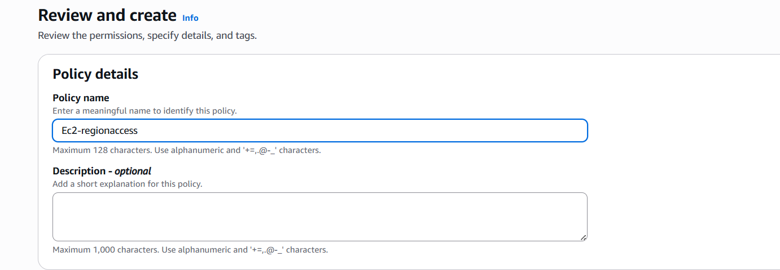
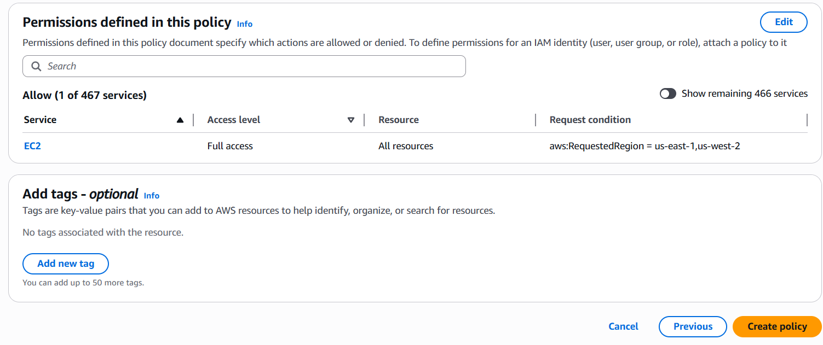
- verified policy
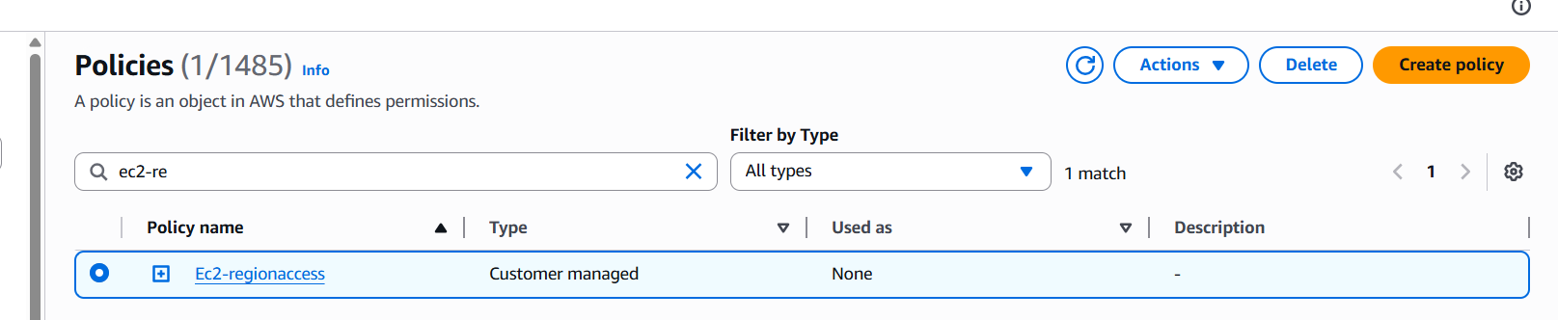
Added policy to the user I have created
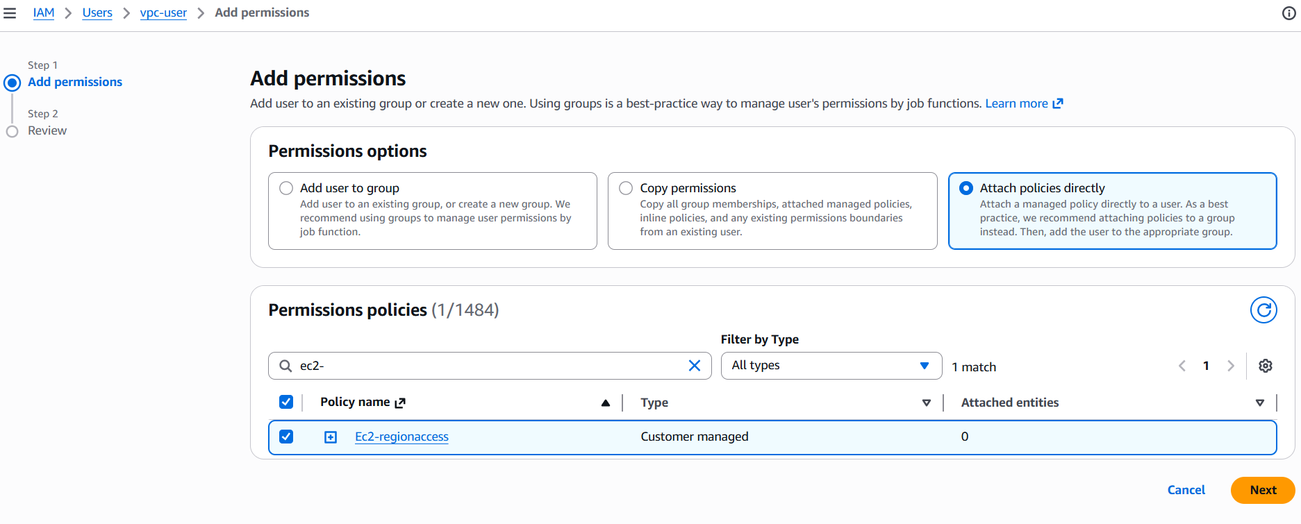
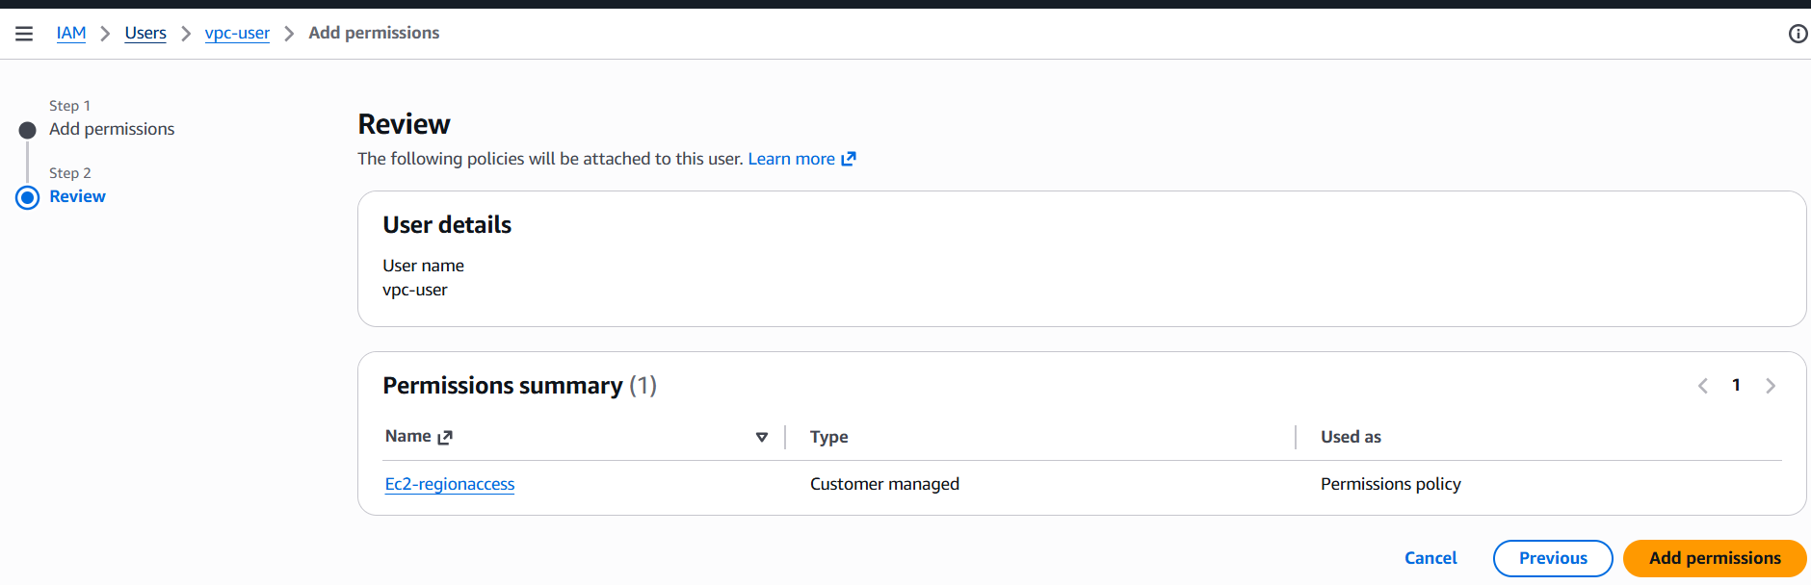
-Checked the policies to verify

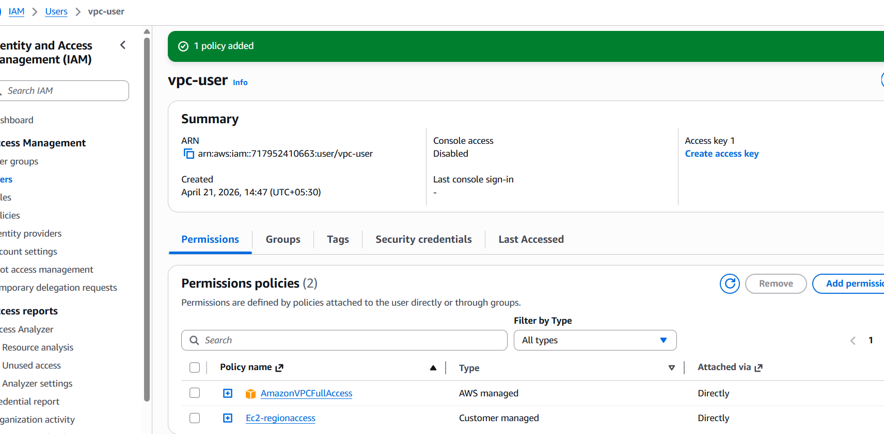
6. We have two accounts: Account A and Account B. Account A user should access an S3 bucket in Account B.
go to amazon S3Bucketscreate bucket name amzw-s3-pinky-bucket(my name or any unique name will be give)
create bucketthen go to add anyfiles in that file and folders we can see our files

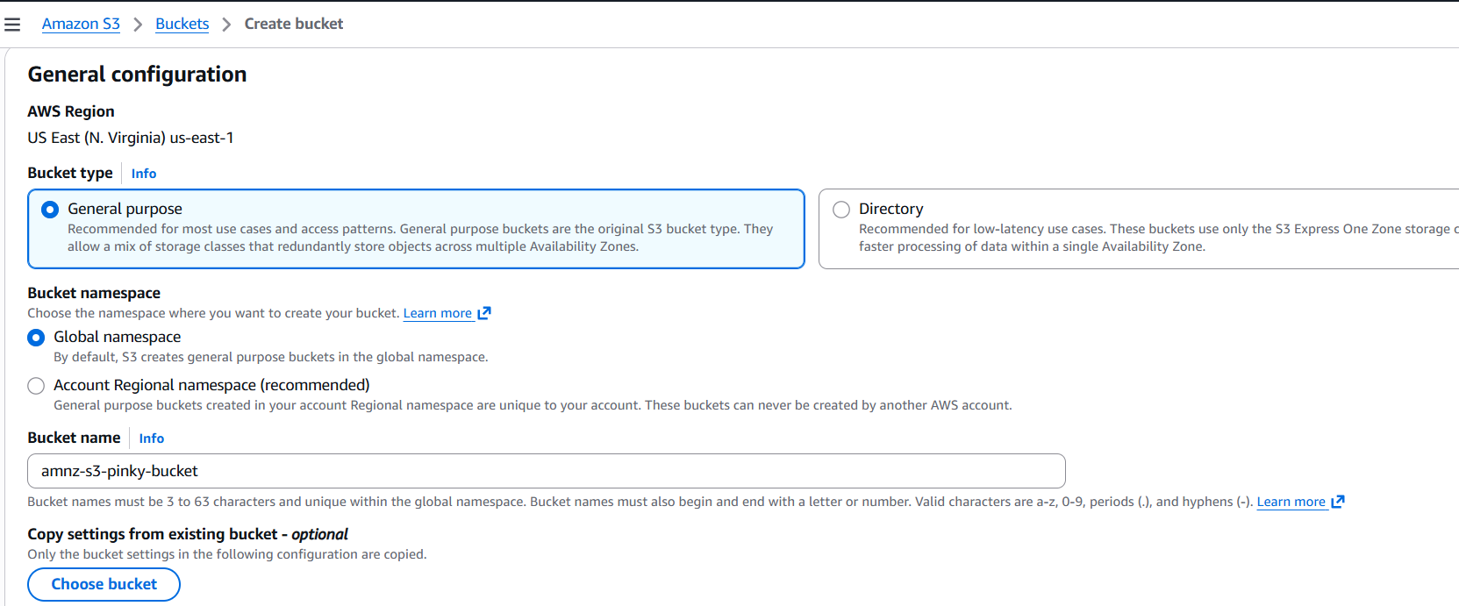
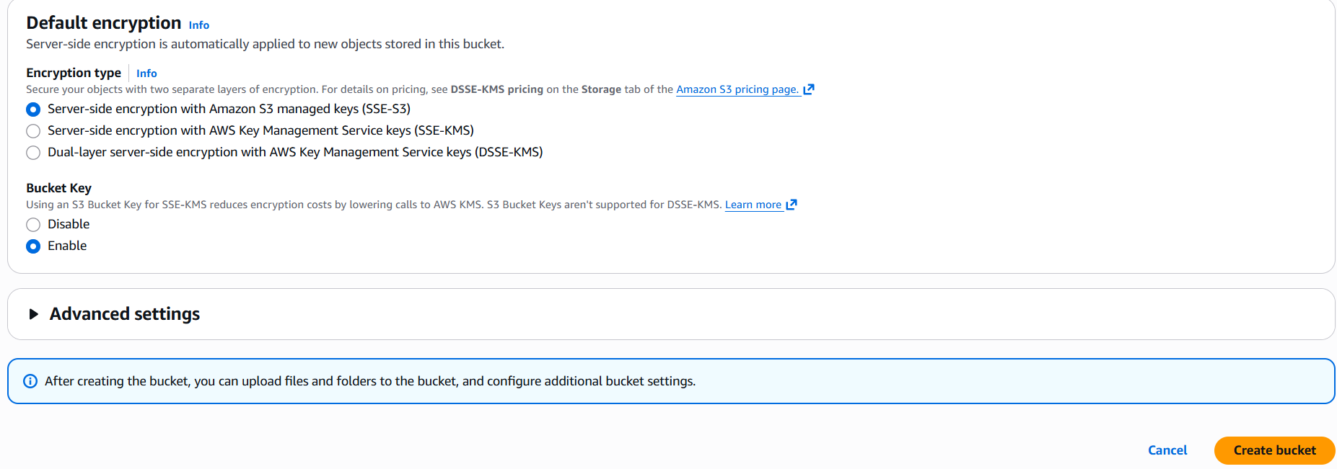
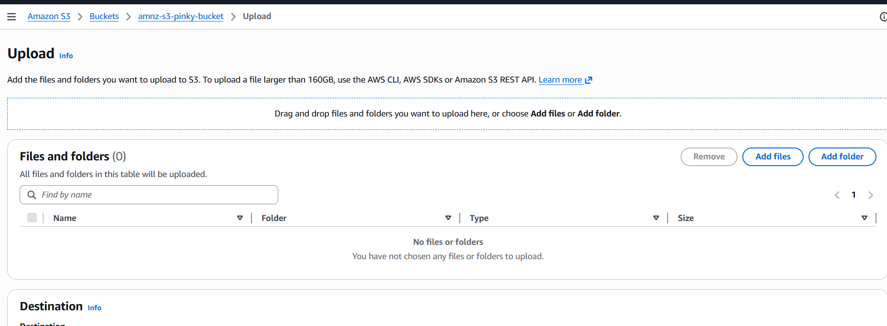

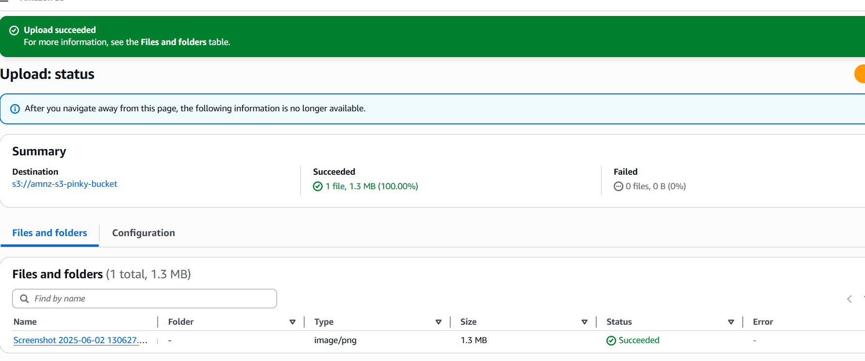
go to permissionseditscroll down
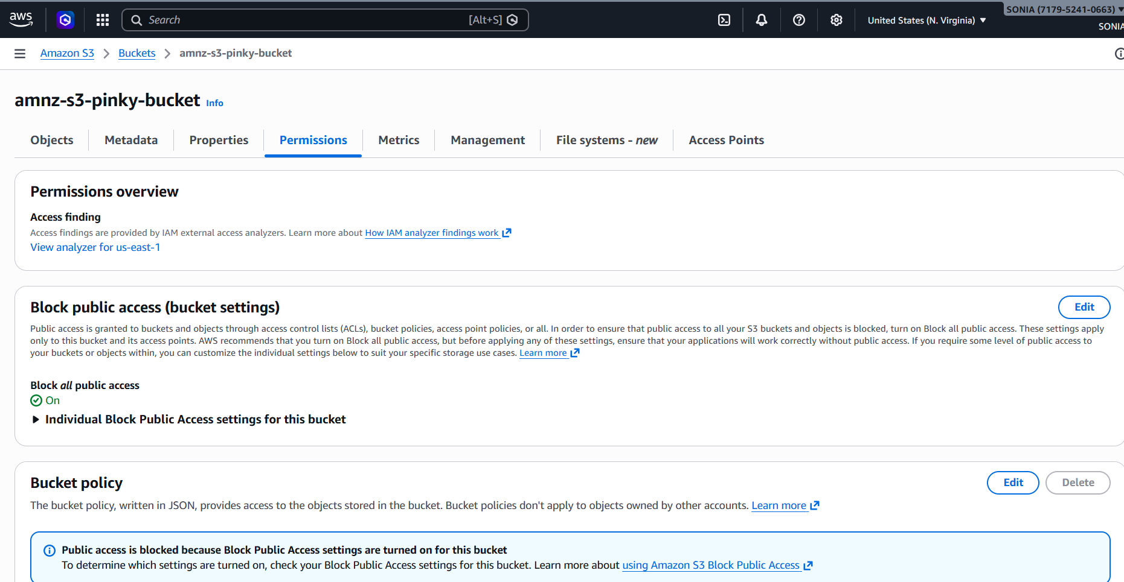
I have added policy to allow account bhargavi to access my bucket

in this 1st we can give bhargavi user idin last line I want to give my bucket arn number.-->I able to acces by bucket in sony git bashshe will configure with their access keys and passwordaws s3 ls s3://amzn-s3-pinky-bucket ….>here I can see my bucket as been showed in her git bash.
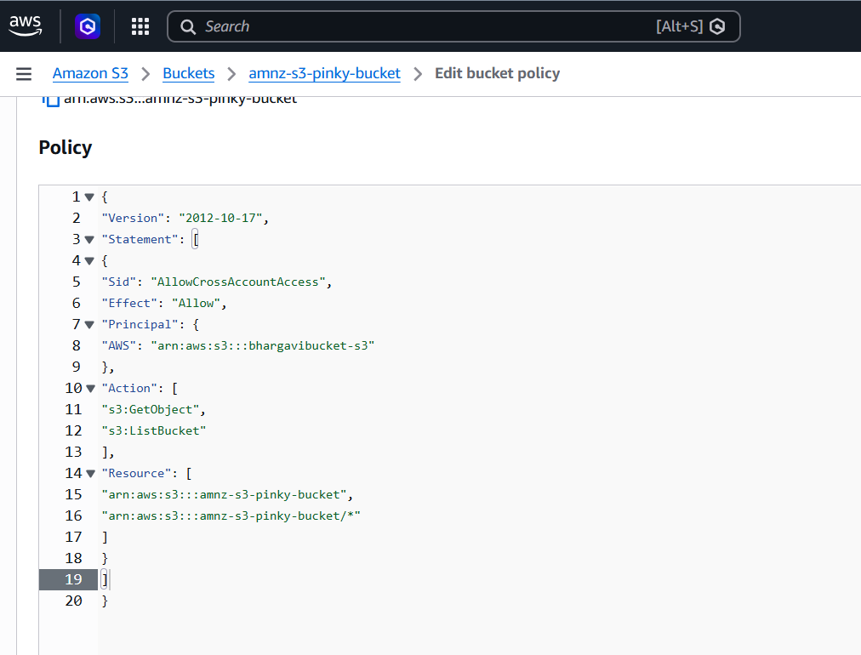
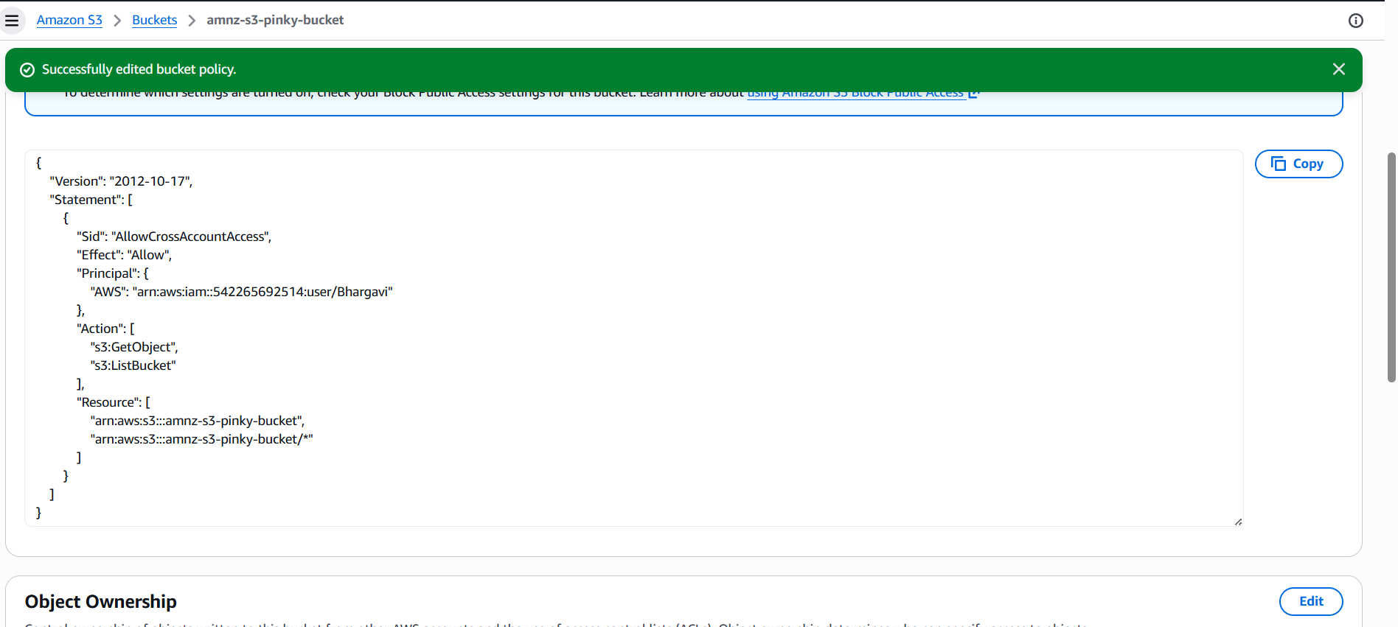
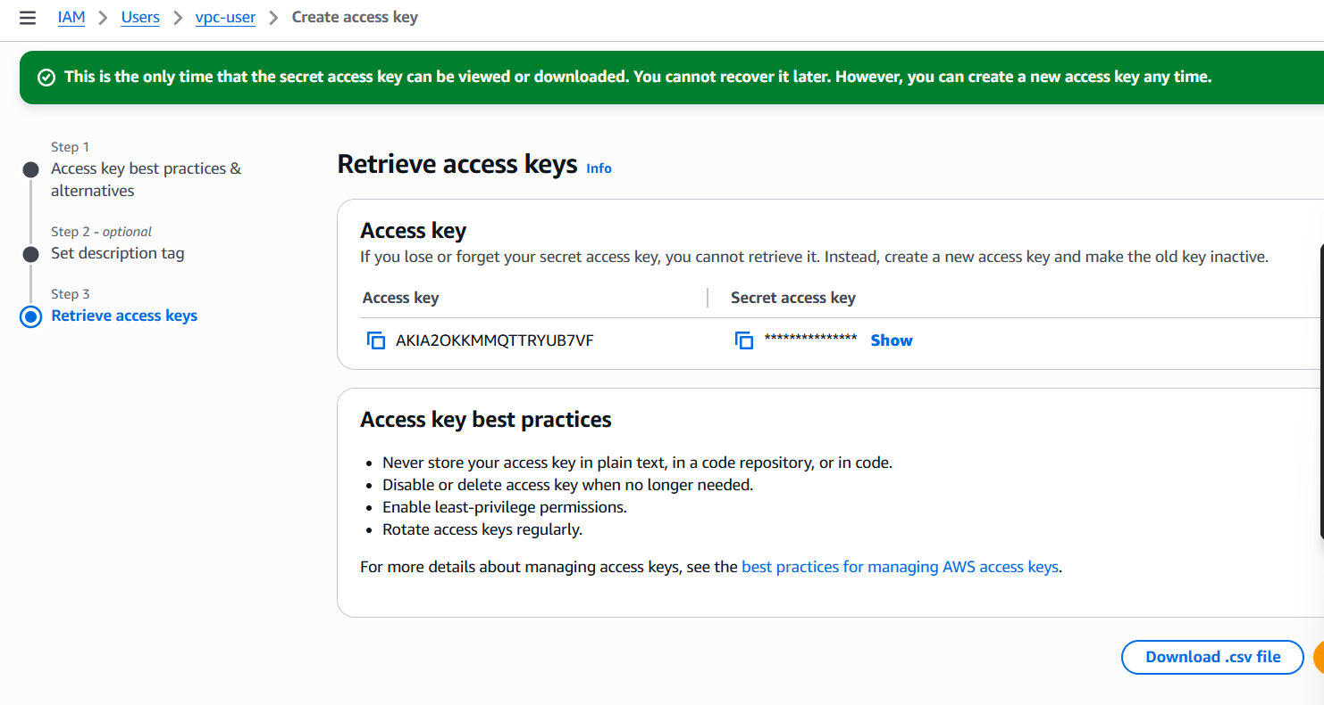
Now sony account is able to access by bucket
